Design and Implementation of a Telerobotic End Effector, Computer Vision, and Environmental Sensor Suite for Automated Agriculture

Sustainable Ag Project VIP Team
[Team Members: Weibo Peng, Andy Huang, Anlon Mao, Weixiang Wang, Kayla Longboy, Alan Gan, Daniel Daren]
May 6 2026
Table of Contents
Table of Contents 2
Relevance (0.75 - 1 page) 4
Problem Statement (0.5 - 0.75 pages) 5
Overview 6
Deliverables 6
Results and Discussion 6
End effector: Iteration 1 8
Deliverable - R1A 8
Requirements 8
Design or Justification 8
Results 9
End effector: Iteration 2 10
Deliverable - R1B 10
Fully functioning robotic “claw” hand-held gripper, capable of picking up lettuce. This is the second design iteration and seeks to improve upon the first. 10
Requirements 10
Design or Justification 10
The gripper arm is the second iteration of the first one. It seeks to improve upon the first iteration by reducing the motor count. It is a significant step forward in improving the overall efficiency of the effector design and in achieving the goal of keeping affordability in mind. 10
Rather than servos, this assembly uses a single stepper motor that is translated to linear motion on the vertical axis, allowing for the gripper to open and close using a cantilever mechanism. The servo is controlled via software through Arduino. A GUI wrapper was developed to streamline the development. 10
Summary 11
Camera and imaging equipment 13
Deliverable - R2 13
Requirements 13
Design or Justification 13
Results 16
Summary 17
Software controls and scripts for motor control 18
Deliverable - R2 18
Requirements 18
Design or Justification - Process 18
Results 18
Summary 19
AI Model Training for Tip Burn Detection 20
Deliverable - G1 20
Requirements 20
Design or Justification 20
Results 20
Summary 20
Data Collection and Storage for Greenhouse Monitoring 21
Deliverable - G2 21
Requirements 21
Design or Justification 21
Results 21
Summary 21
Sensor Implementation for Environmental Monitoring and pH 22
Deliverable - G3 22
Requirements 22
Design or Justification 22
Results 22
Summary 22
References 23

Relevance (0.75 - 1 page)
[Describe the relevance of the overall issue before focusing the narrative on a singular issue which should be addressed. Cite your references and use quantified impacts and statistics where possible to communicate the magnitude of the impact and who is affected.]

[This section was not written in paragraph form nor supported with cited references in the proposal. This must be addressed. The points that have been identified are good.]

- Support local organic businesses
- Increase workers efficiency and productivity, but not overtaking jobs
- Increase local food production and quality since Hawaii heavily relies on food importation/becomes very expensive for consumers
- Boosting the Hawaii economy by exporting Food and agricultural plants (Hawaii special) and not just relying on tourism.
Hawaii’s food system is currently in a difficult position. The reason behind this is that we live on an island, we rely on ships and planes for almost everything we eat. According to the Department of Agriculture and Biosecurity (2026), Hawaii imported about 233.8 million dollars' worth of food in 2024. This dependency is a major risk because if shipping is ever delayed by a storm or by a global crisis, our food supply could easily run out in just a few days. Which makes living here really expensive. In 2026, Honolulu was ranked as the most expensive city in the U.S. for groceries with residents paying 31% more than the national average (Cheapism, 2026). By growing organic food locally, we can lower these costs and make sure our community always has access to fresh produce.

Boosting local farming is also the best way to help Hawaii’s economy. Right now, the state relies heavily on tourism, which makes up about 21% of our economy (Department of Agriculture and Biosecurity, 2026). If fewer people visit Hawaii, the whole state suffers. By using technology to grow and export high-value local plants, we can create a more stable economy with good-paying jobs that don’t depend on tourists.

One of the biggest problems we face is that our farmers are getting older. Recent data shows that there are over 5,600 farmers in Hawaii aged 65 or older, but only 765 farmers under the age of 35 (Department of Agriculture and Biosecurity,2025). As these older farmers retire, we are losing the people we need to grow our food. Our project uses robotics and AI to help solve this “labor gap” . We aren't trying to replace workers; we are building tools that allow fewer people to do more work, helping the next generation of farmers keep up with demand.

The main issue we are focusing on is making “Controlled-Environment Agriculture” (like high-tech greenhouses) work for Hawaii. Research shows that using these systems can
increase crop yields by five times while tutting the use of pesticides by 50% (University of Hawaii CTAHR, 2026). However, these systems are hard to manage and need constant attention to prevent problems like “tip burn” in lettuce or water chemistry changes. Our project which combines robotic arms, smart cameras, and sensors creates an automated “safety net” for farmers. This technology makes local organic farming easier, more productive and more profitable for the people of Hawaii.

Reference (APA 7th Edition)

Cheapism. (2026, March 4). These 10 Cities Have the Highest Grocery Prices in 2026. https://www.cheapism.com/highest-grocery-prices-2026/
Department of Agriculture and Biosecurity (DAB). (2025). Statistics on Age, Sex, and Race/Ethnicity of Hawaiʻi Producers. State of Hawaiʻi. https://dab.hawaii.gov/stats-producers-2025

Department of Agriculture and Biosecurity (DAB). (2026) Market Analysis and News Branch Statistics on Total Agricultural and Food Imports and Exports. State of Hawai’i.
https://dab.hawaii.gov/add/files/2026/02/Hawaiis-Agricultural-and-Food-Imports-and-Exports_Feb.2026_final2.pdf
University of Hawaii College of Tropical Agriculture and Human Resources (CTAHR). (2026). Hanai’Ai: Screenhouses Support Organic Pest Management and Yield Stability in Hawaii. https://cms.ctahr.hawaii.edu/soap/Hanai-Ai

Problem Statement (0.5 - 0.75 pages)
[Describe the objective and relevance of the proposed engineering problem(s) to be solved. Ensure it is clear how it impacts the overall issue. Further define the problem with a description of the technical requirements and other relevant requirements such as safety or environmental, sustainability, economic, global, cultural, or societal factors as applicable. Clearly identify the client or intended audience.]

[This section was not written in paragraph form nor supported with cited references or quantified values in the proposal. This must be addressed. The points that have been identified are good. You will likely need two paragraphs. The first can communicate some objectives and tie it into the relevance. The second should provide key requirements to aim for.]

- Addressing food security by incorporating new tools (robotic arm) for increased production
- Effectively produce by developing techniques to identify bad crops (lettuce)
- Increase the efficiency and yield of the harvest by effectively implementing robotic/autonomous technologies (arms, computer vision, machine learning) economically.
- Grow crops in a controlled environment with sensors (light level, temperature, humidity, CO2, pH) for optimal yield, quality, and growth rate.
- Robotic arms could struggle to pick things up accurately without visual guidance/hard to train without documentation

Overview
[Provide a brief overview of the design and concept of the solution worked on this semester. Introduce any terms and concepts that are relevant and critical to understanding the more in depth information to follow. You should have some sketches or images that are annotated and described in the text of this document.]

Deliverables
- R1: Fully functioning (telerobotic) robotic arm with properly assembled effector (design TBA), capable of handling lettuces at various stages of growth.

- R2: Mount/integrate external cameras to track objects and assist the robotic arm, designing stable mounts, and withstand vibration/shakiness during operation.
- R3:
- G1: Use image processing and train an AI model to detect browning in lettuce
- G2: Store monitored data in a web server.
- G3: Fully integrate the pH probe and amplifier to monitor the pH levels of the fish tank, including a solar energy source for it.
- G4: (Semester 2) Fully integrate external cameras and sensors to monitor temperature, relative humidity, and light level of the greenhouse.

Results and Discussion
[Separate this section into several subsections. Likely each subsection will be at least two pages. For each subsection, include the following as appropriate.
- Identify which deliverable(s) each addresses. If not fully clear, you can elaborate further to ensure the deliverable / objective is clear.
- Provide sketches and pictures that illustrate the key mechanism or specification of the solution. These can be throughout the subsection to support all points.
- Provide a justification for why the solution will / does work.
- Provide experimental results and an analysis of the results.
- Provide a summary and as applicable alternative solutions or components with the necessary specifications.]

R1: End effector, Iteration 1

Deliverable - R1A
Custom handheld end effector, capable of grasping lettuces and other plant matter at various stages of growth.

Requirements
Types of Lettuce that the Gripper can Handle:
- Butter Lettuce
- Romaine Lettuce

End effector:
- PLA (Generic) fingers and body
- Bottom-sided camera mount for computer vision
- Controlled by the leRobot software, with modifications to the project code to allow for a three-motor gripper.

Design & Justification
Design:
The design of the end effector was primarily inspired by an arcade claw machine, where we have 3 claws to grasp the object with. The end effector assembly weighs 526.5 grams.

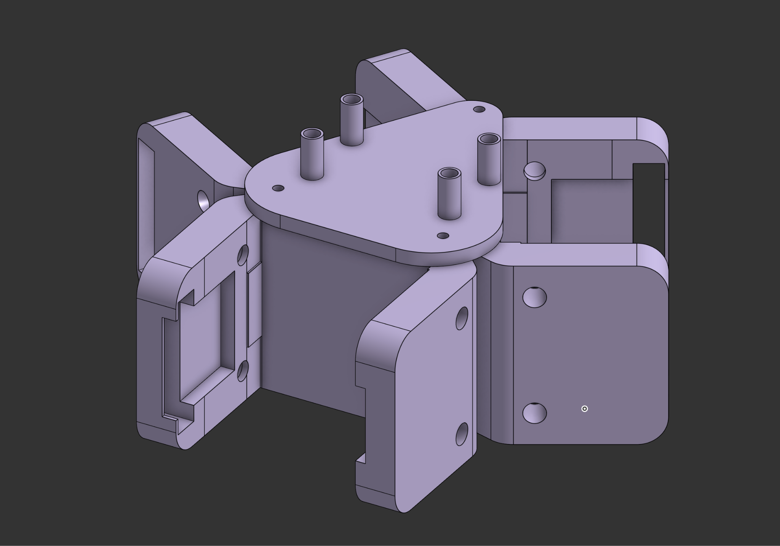
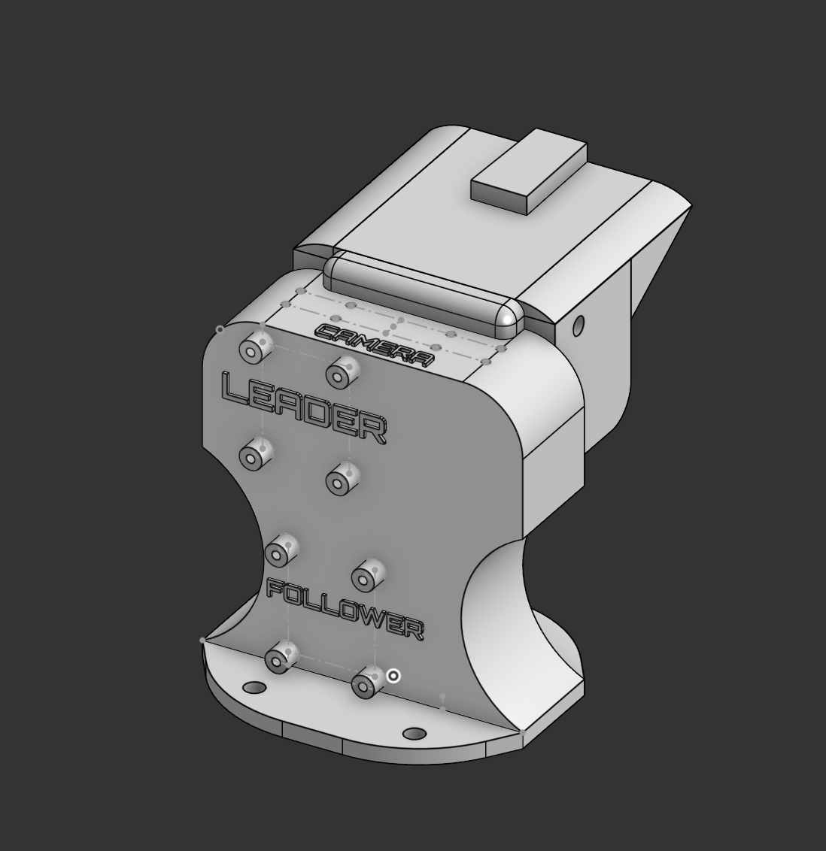
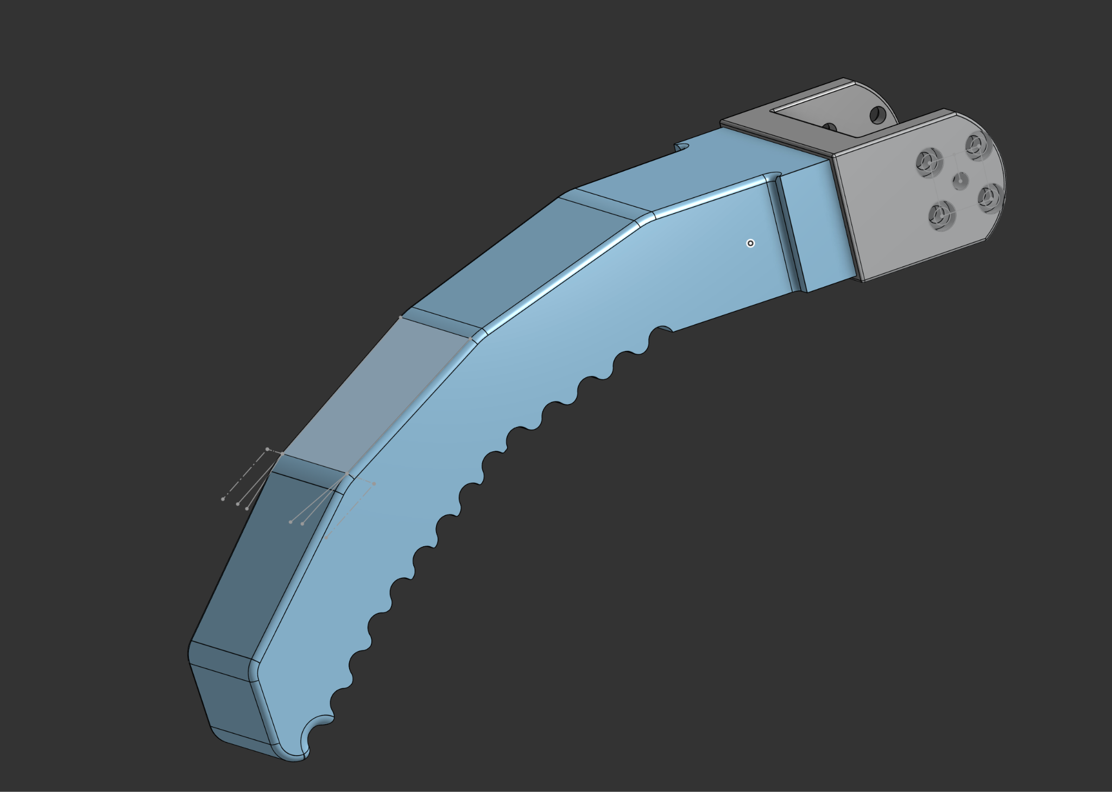
Figure: (1) Handle adapter, (2) Effector finger, (3) “Tri-adapter” mount for Feetech servos
Justification:
We believe that having 3 claws is the most efficient way to pick up an object from the ground, as we predict that it is also the fastest way to pick it up.

Results
After the assembly of the prototype gripper, we tested it on two types of lettuce: (1) Butter lettuce and (2) Romaine Lettuce. Primarily, we are looking for the following things: (1) The gripper functions as expected with all three individual fingers moving at the same time, (2) The ability for the gripper to hold an entire head of lettuce without damaging the lettuce, (3) The ability for the gripper to handle multiple “angle of attacks” when grasping the lettuce, whether off center, perpendicular, or from above.

All three tests were performed, and the following results have been obtained for each of the following categories:
(1) Gripper functions as expected:
The gripper performed fairly well upon first power-on. Though there is a noticeable delay with one of the fingers, which could have been caused by how the code for the gripper was written. For this gripper, it is handheld because it was not designed to be attached directly to a robotic arm. This is primarily due to the weight constraints of the robot arm; the weight of the entire gripper assembly is very close to the stall torque specified in the servo’s specifications.
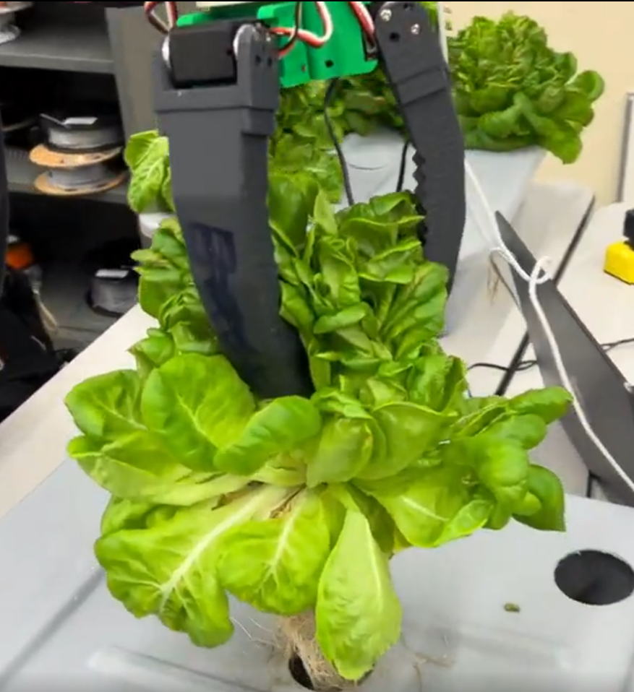
Figure: Gripper Grasping Butter Lettuce

(2) The ability to hold an entire head of lettuce without damage:
This test went very well and exceeded initial expectations. We were initially concerned about the amount of pressure the claw can exert since all the pressure is concentrated towards one point. However, this did not happen, and the gripper was able to hold a full head of lettuce without damage. This was even true for
lettuces that were considerably aged and wilting.

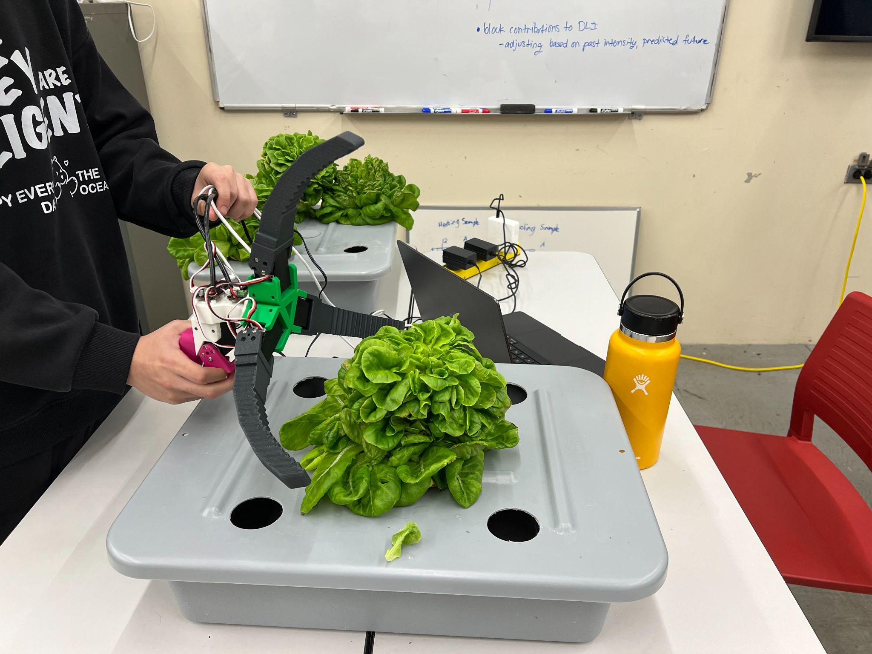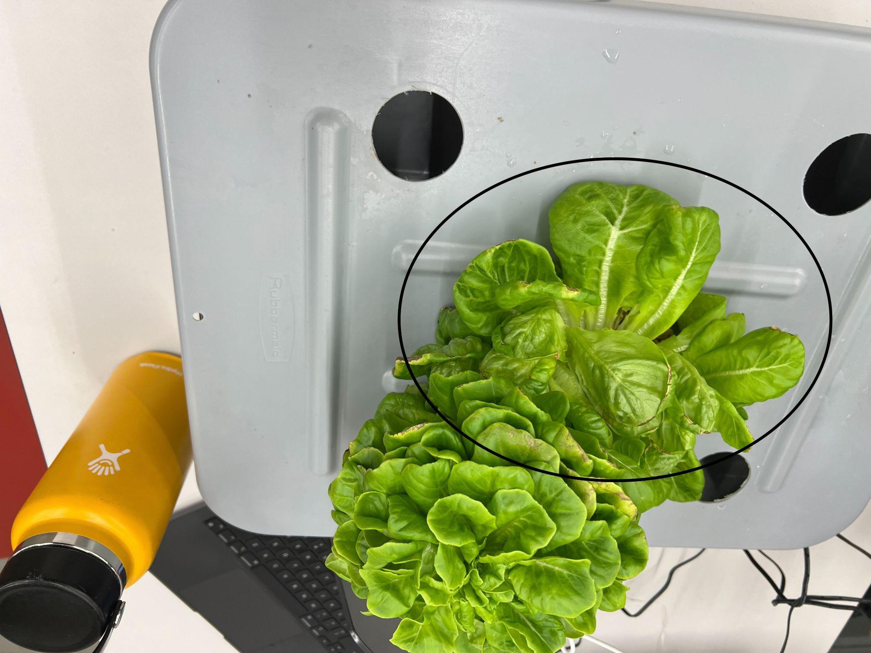
Figure:(1) Gripper Grasping Butter Lettuce, (2) Poor condition of lettuce that is being grasped

(3) The ability to grasp lettuce from different oncoming angles: This was the most recent test after all the prior constraints and designs had been verified. We simulated several approaches by hand towards the lettuce at different angles. This is to ensure maximum flexibility so that the robotic platform is not restricted to only certain movements. We tested it by approaching the lettuce from above, perpendicularly, and off-center; all three tests yielded successes.

Summary
Overall, the first iteration of the gripper was successful in meeting four requirements for deliverable 3, which are: (1) Do literature or internet research on various solutions, (2) Gather measurements and other details for the task, (3) Design a 3D printed prototype and necessary controls, (4) Test the model. We were unable to meet the other requirements due to the physical constraints of the robotic arm (end effector exceeds the weight limits of the SO101 arm). We were also unable to train a new VLA model due to the complexity of the task and the lack of additional camera hardware.

—----------------------------------------------------------------------------------------------------------------------------

End effector: Iteration 2

Deliverable - R1B
Functioning robotic “claw” hand-held gripper, capable of picking up lettuce. This is the second design iteration and seeks to improve upon the first by reducing motor count.

Requirements
End effector, iteration 2:
- TPU Soft Gripper Fingers
- Software-controlled operation (Arduino – PySerial interface)
- Single motor driver
- Capable of grasping lettuce

Design & Justification:
The gripper arm is the second iteration of the first one. It seeks to improve upon the first iteration by reducing the motor count. It is a significant step forward in improving the overall efficiency of the effector design and in achieving the goal of keeping affordability in mind.
Rather than servos, this assembly uses a single stepper motor that drives a linear motion screw, allowing the carriage to move up and down, which retracts/extends the fingers depending on the direction of motion of the carriage.

The first task was to design the assembly itself, which was created on Onshape and 3D printed. The design is highly reminiscent of an arcade claw machine, using a similar cantilever mechanism to prevent the central carriage from spinning whilst the stepper motor is being driven.

The printed assembly was of standard PLA plastic, and the fingers were printed using TPU for flexibility while maintaining rigidity.

Some hardware was required. Several M2 threaded shoulder bolts were used to attach the beams and fingers to the “core” and central carriage, with nyLock bolts and nylon washers to prevent slipping while in motion.
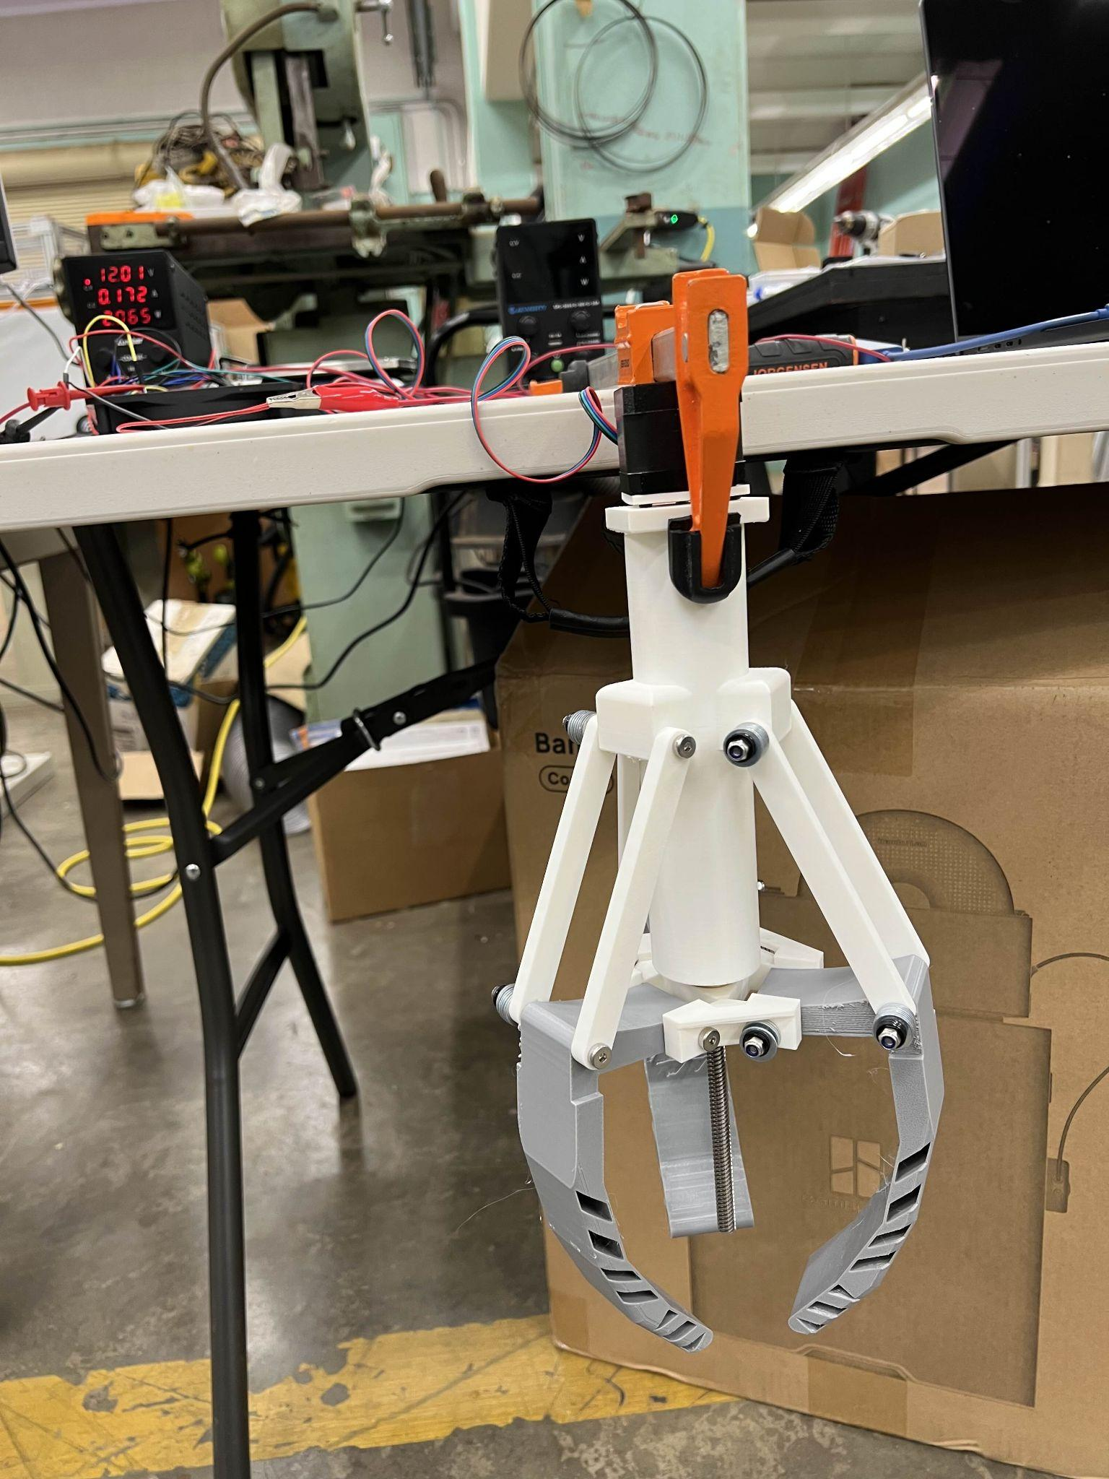
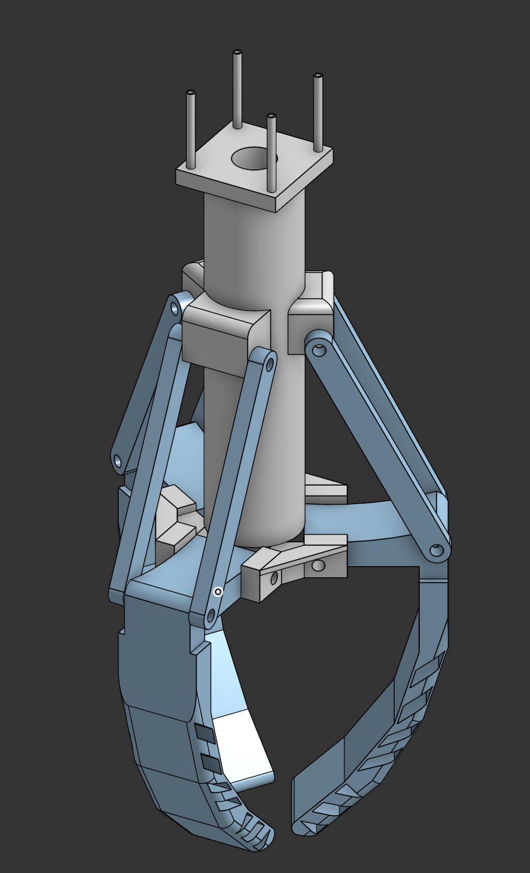
Figure: (1) Render of assembly, (2) Physical assembly attached to the table
Next, we must consider the electronics. The most important aspect is the motor and its controls.

Motor:
The motor selected was the stepper motor with model number 17HE15-1504S. This is a bipolar two-phase stepper motor, which is designed for high torque and operational efficiency. It is composed of two individual coils that drive the motor assembly.

The motor runs at 1.5 amps of input current at a potential of 12 volts, as specified in the motor driver specification sheet and the stepper motor data sheet.
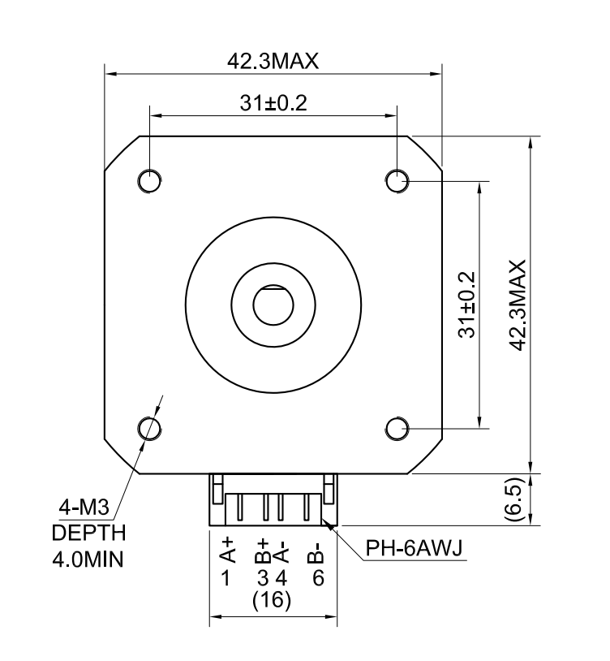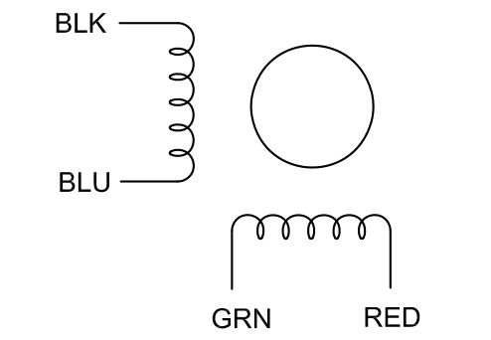

Figure: (1) Physical dimensions with pinouts, (2) Schematic symbol of this particular motor.
*Derived from 17HE15-1504S data sheet.
Driver:
To interface between a computer system and the motor itself, an interlink is required. This is fulfilled by the use of a motor driver. For this design, we utilized the Big Easy Driver (ver 1.2), which was designed by Brian Schmalz, and the PCB was manufactured by Sparkfun Electronics.

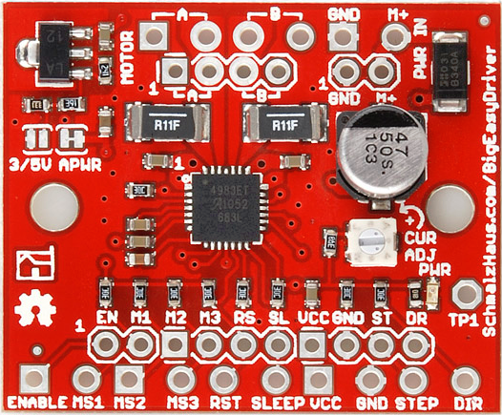
Figure: Big Easy Stepper Driver PCB

This PCB supplies more than enough current, capable of handling up to 2A of current per phase, and the actual current can be controlled by a screw-operated potentiometer built into the PCB, allowing current to range from 0 amps per phase up to 2 amps per phase. It can handle up to 35 V for the motor drive voltage, but 12V DC is sufficient for this motor.

The actual operating principle of this board is described as follows:

This board is supplied by 12 volts DC through the M+ and GND pins. Then, the DIR pin is either pulled to high or low (alternates between 0V and 5V square-waveform). Depending on whether a high or low voltage signal is applied to this pin will change the direction of the stepper motor. The signal for DIR is sampled upon the rising edge of the STP pin.

The STP pin is the most important here. The STP pin takes between 0V and 5V (Peak), where alternating between 0 and 5V causes one step to be taken (also called a rising edge). This pin can be continuously driven at high frequencies (or very small delays by the relationship f = 1/T) for seamless motor control.

For this gripper, we do not utilize the microstep function of this board for simplicity’s sake, though it is wired between the Arduino and the controller if it is indeed needed for the future; we have found that using the STP pin alone is sufficient for smooth movement.

Finally, there are also several other mandatory pins, which include the EN (enable pin), pulling this pin low allows for control, while if pulled high disables all other outputs. VCC and GND are unnecessary, as this is basically just 5V from the PCB that can be used to power other components (at small currents)

Arduino:
The Arduino allows a computer to interface with the motor driver and sends a digital signal to the controller, allowing the motor to operate depending on the frequency of the pulses and whether the signal is high or low.

The Arduino board that was selected is a third-party board, called the Red Board, manufactured by Sparkfun Electronics. It uses the same chip as the Arduino Uno, but with some improvements, such as a lack of exposed solder joints due to the entire PCB having surface-mounted components.
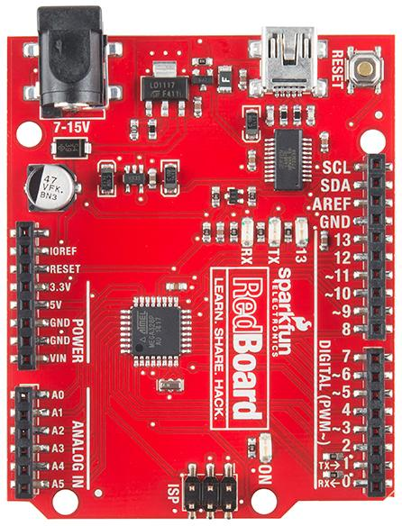
Figure: RedBoard Arduino “clone”

Because the Big Easy Driver board’s logic is controlled by a digital signal, the STP, EN, DIR, and MS1-3 terminals are connected to the digital pins of the Arduino (namely digital pins 3-8).

The operation is fairly straightforward. We first declare a pin on the motor controller board to a digital pin on the RedBoard:

#define stp 3
#define dir 4
#define MS1 5
#define MS2 6
#define MS3 7
#define EN 8

This allows us to give a constant value to a variable before compilation and is very memory efficient.

The following is a snippet of the Arduino code, described as pseudocode:
(Note: Arduino executes code sequentially.)

CREATE variables:
user_input
x
y
customlooprate

Setup:
Set the step pin as output
Set the direction pin as output
Set the microstep pin as an output
Set the enable pin as an output

Reset all motor driver pins
Start serial communication at 9600 Baud

Main Loop:
IF serial data is available → Read one character from serial, then store as user input
IF user_input is either “o” or “c” → Enables motor driver, calls function with 700 steps, then calls the function to reset motor driver pins
ELSE IF user_input is either “f” or “b” → Wait briefly, read an integer from the serial, store as customlooprate variable, enable the motor driver, call the opengripper() function, and reset the motor driver upon loop exit.

Open Gripper Function:
Set direction pin HIGH

Repeat customlooprate times:
Turn step pin HIGH
Delay 1 ms
Turn step pin LOW
Wait 1 ms
Exit Loop
Returns to the main loop and listens to the serial port for the next string
……

Python:
Sometimes it is cumbersome to control the motor through the serial monitor on the Arduino IDE. To resolve this problem, a simple GUI wrapper was developed to help reduce the frustration often seen when dealing with terminal-based scripts.

The two main Python packages utilized were customtkinter (GUI) and pySerial (establishes a serial connection over USB).

It is unnecessary to completely describe the code itself, as the Python project itself is completely optional and is not required to operate the gripper.

The program itself has some safety features, such as preventing the user from sending signals to the Arduino while the motor is in operation, amongst others.
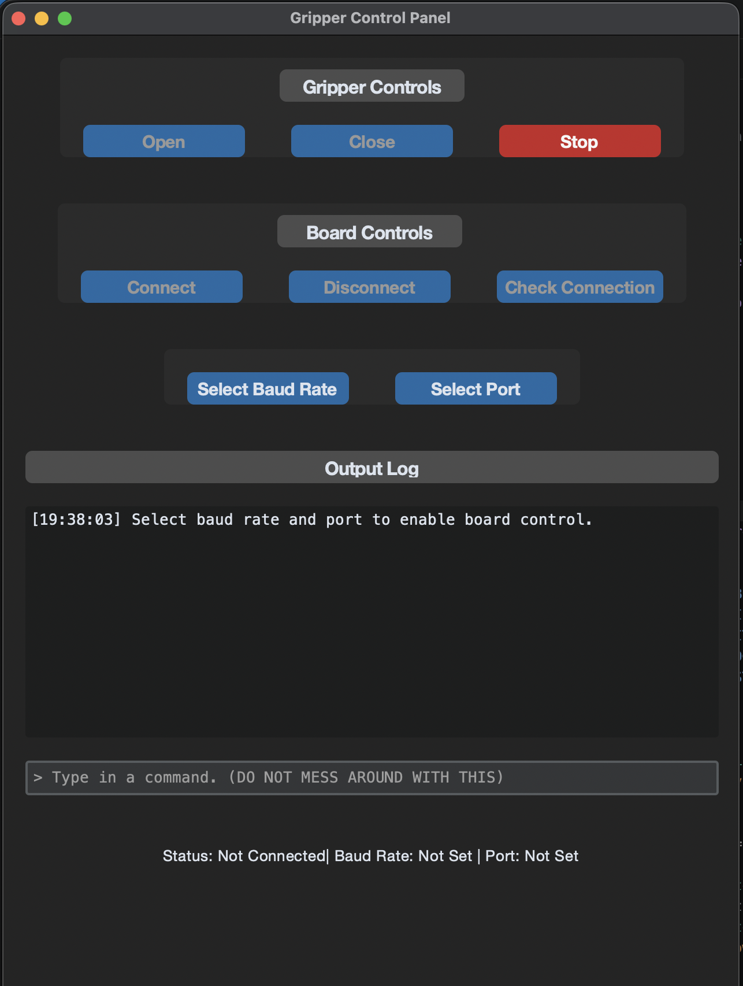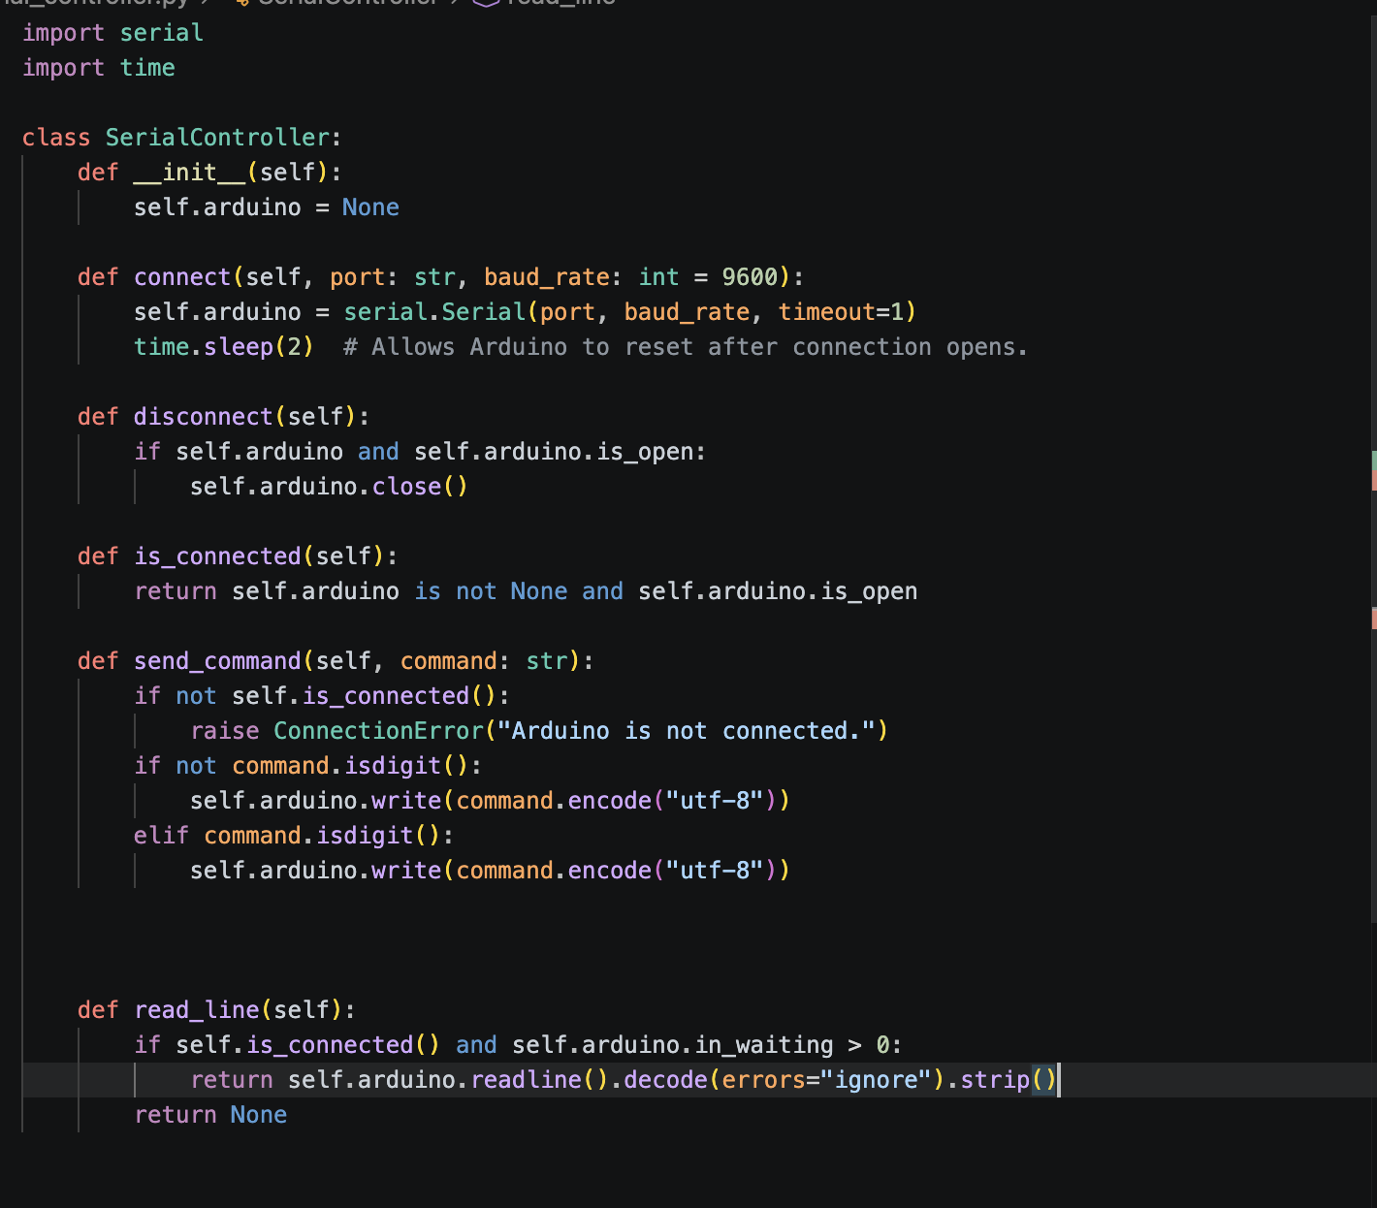
Figure: (1) GUI, (2) Code that directly “talks” with Arduino over serial communication

Results:
Due to time constraints, the gripper and code were developed over three weeks (started mid-April and completed on May 6th). So there were not many opportunities to test the gripper. However, we were able to quickly test if the gripper properly functioned by having it grasp a lettuce.

From testing the gripper, we noticed that the gripper was able to grasp itself, although the motor stalled quickly when slight pressure was applied to the lettuce. This is strange, as the motor itself is not underperformant and is capable of exerting fairly high torques. This could be attributed to the limited current, as using a DMM (digital multimeter), we observed that the maximum current through the entire circuit (from hot to ground) was only 600 mA, which was well below the rated spec of the stepper motor. Upon further analysis, we discovered the motor controller board had a faulty potentiometer. Even when turning the potentiometer both fully clockwise and counterclockwise, the current supplied will not budge past 600 mA.

The motor was also loud, and there was a significant grinding noise heard as the carriage moved up and down the screw. However, linear motion is still smooth, and this noise can be reduced by applying a lubricant, but still worthy to mention as having a noisy gripper is suboptimal.

The motor control board also ran hot, with it being nearly impossible to handle with bare hands. In the future, this issue can be mitigated by cooling the central IC with a thermal pad and/or heatsink. This heat, however, does not affect the performance, and the board can comfortably handle up to 2.2A without requiring external cooling.

The Arduino code and Python code worked well together, and there were no real issues or latency. Of course, with the development of any software product, bugs are absolutely expected, and this project is no exception. Over the course of development, many bugs were encountered, such as large delays when driving the STP pin, which was due to many cycles being sucked up by an errant serial print function being mistakenly appended into a for loop.

Summary:
Overall, this design served as the successor to R1A, and even in the midst of time constraints, we were able to come up with a working model and some code to follow along. It was able to grasp a head of lettuce, albeit very poorly, which can be attributed to current-limiting by the motor controller board because of a faulty potentiometer. We were successful in reducing the motor count from three to one, and we plan to use the code developed for this gripper as a base for our next iteration of this project, namely, avoiding the use of fingers entirely.

Camera and imaging equipment

Deliverable - R2
Design and integrate external cameras to track objects and assist the robotic arm, providing clear views of motion while maintaining stability and avoiding interference.

Requirements
Camera Setup/Views:
- Create mounts that capture:
1) Entire movement of robotic arm setting from a birds eye view,
2) Direct POV from robot gripper [for training arm], and
3) Clear movement of gripping lettuce [for end effector view]

Camera Specs:
- Use of USB Cameras with:
1) Resolution of 720P+
2) Interchangeable lens (if needed)
3) Proper FOV for type of mount

Mounting & Stability:
- Must not block robot movement
- Stable mounts with minimum vibration
- Adjustable camera position [for birds eye view]

Lighting:
- Good lighting - clear and lit up work space

Design or Justification
Camera Mount Design [Training Arm]
Prototype 1:
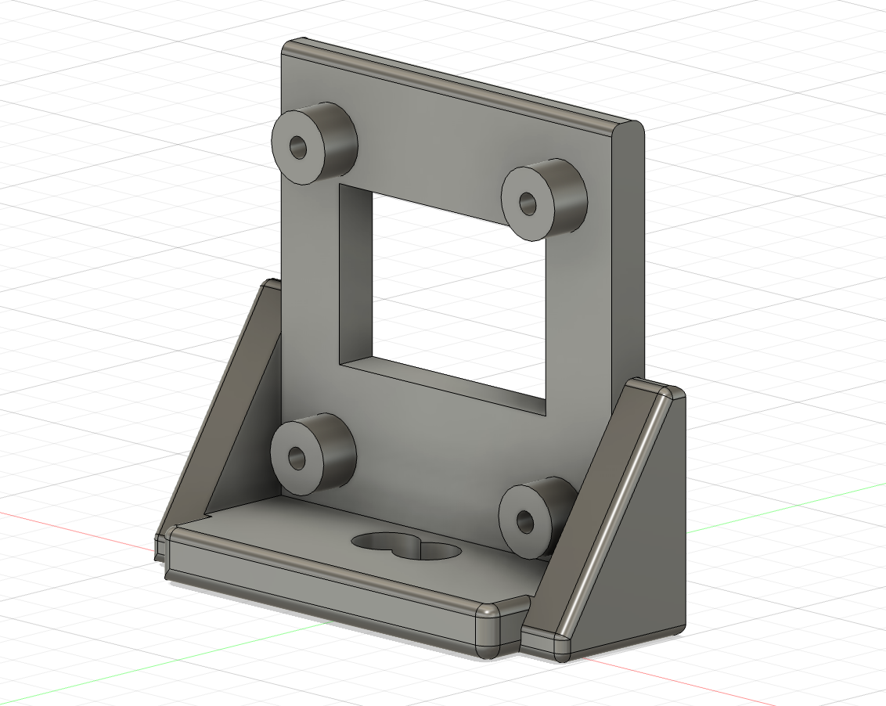
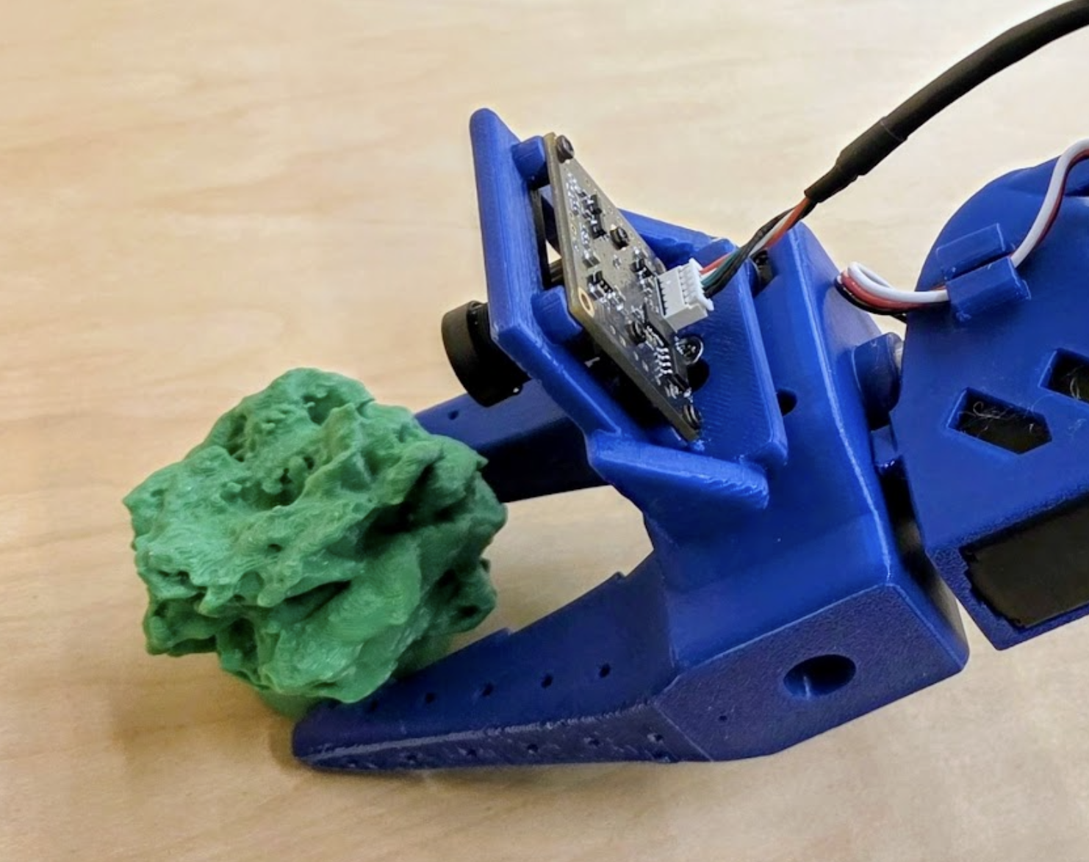
- This design was created with intent to make the camera field parallel to the gripper. On the camera used, its lens sticks out of the board rather than be almost flat. So, I created a design whereas the camera lens is through a hole and is screwed into the mount from the back. The mount perfectly outlined the size of the camera and mounted to the gripper right on top. This type of mount resulted in being too close to the gripper claws and touching the 3D printed lettuce. This meant that the camera view could not see anything and was blocked.

Fig.1 - Prototype 1 Mount Fig.2 - Closeup of camera mounted to arm

Prototype 2:
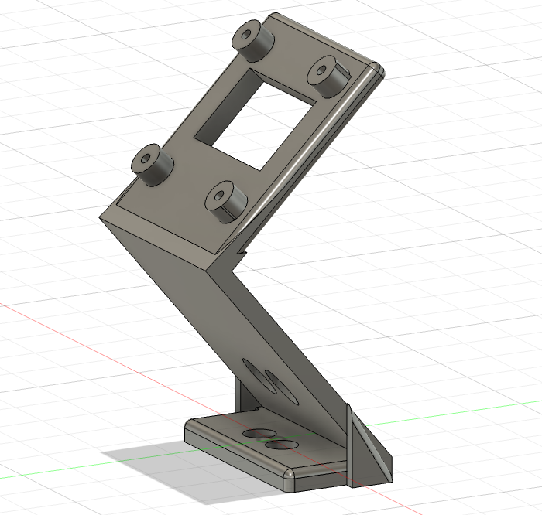
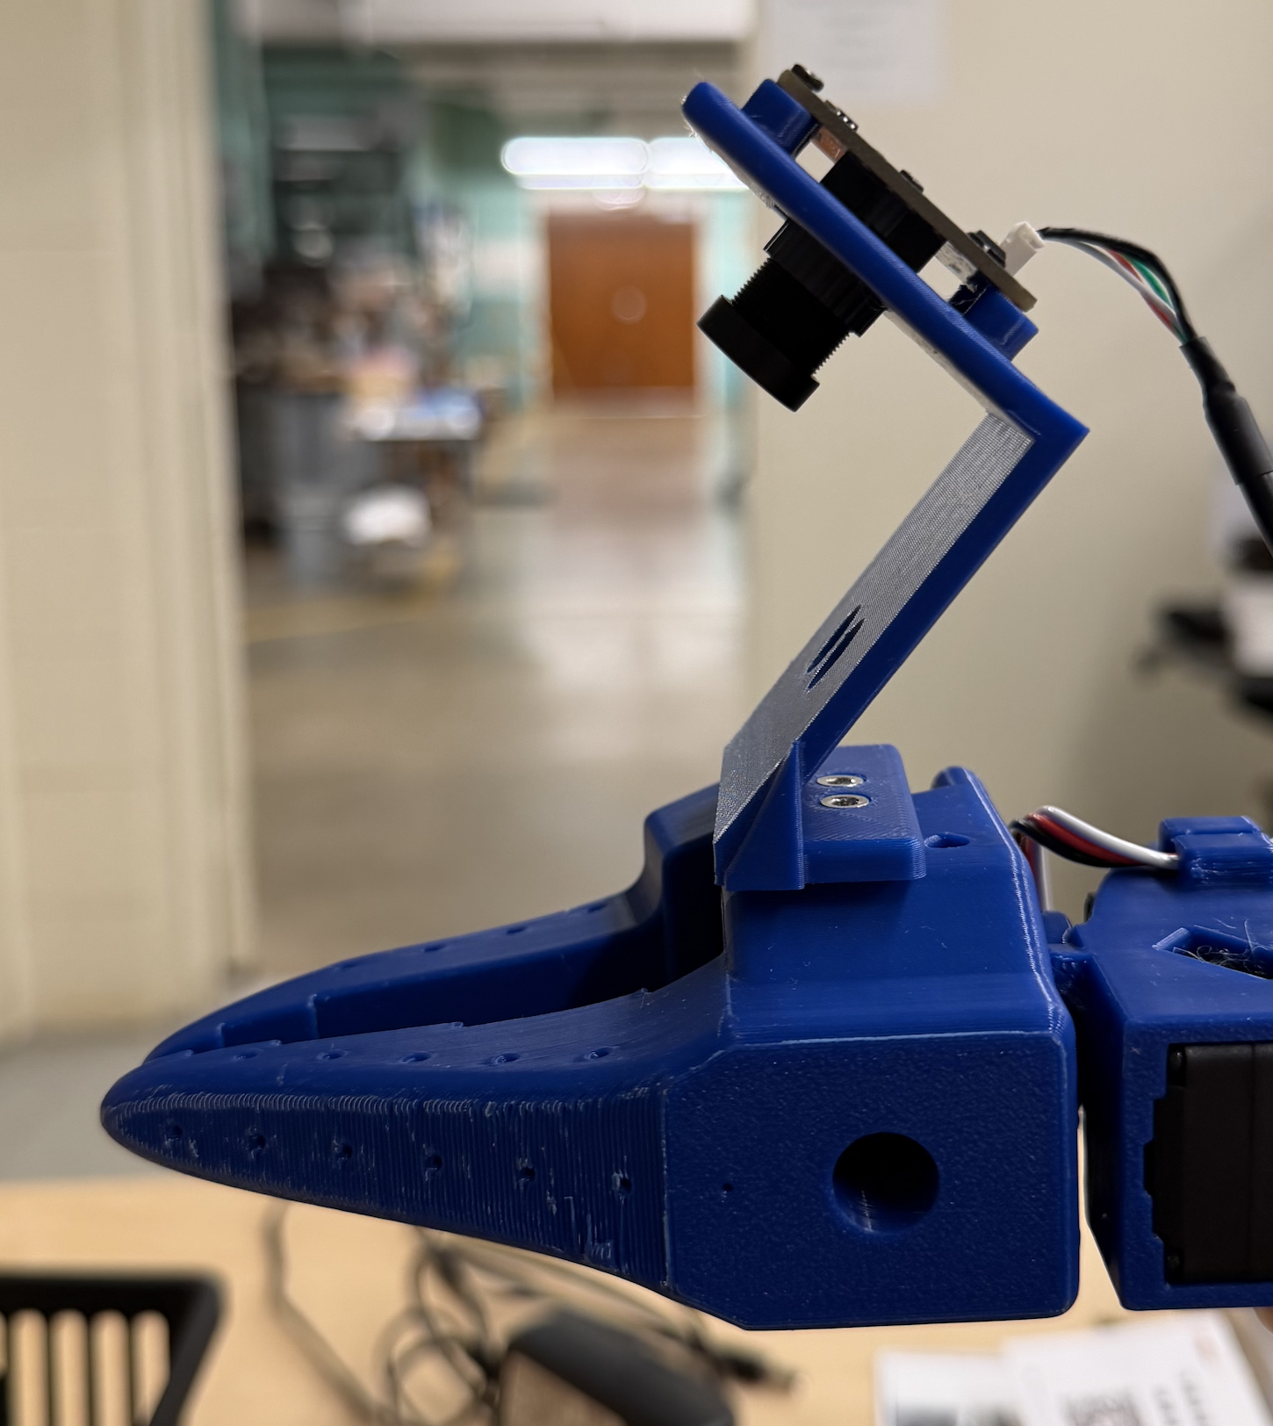
- This design was updated from prototype 1. Since the mounted design in prototype 1 was too close, we had to pull the mount back more and point it at an angle so that we could fully see the gripper motion + lettuce. Prototype 2 used the same camera insert and screw template as prototype 1, however the base below the camera was changed. The base was pulled out around 54mm at an angle of $50^{∘}$ from the flat mounting base. Pulling the camera back at an angle allowed us to fully see the lettuce and gripping motion now.

Fig.3 - Prototype 2 Mount Fig.4 - Closeup of camera mounted to arm

Camera Mount Design [Work Area]
Top Bar (Bird’s Eye View):
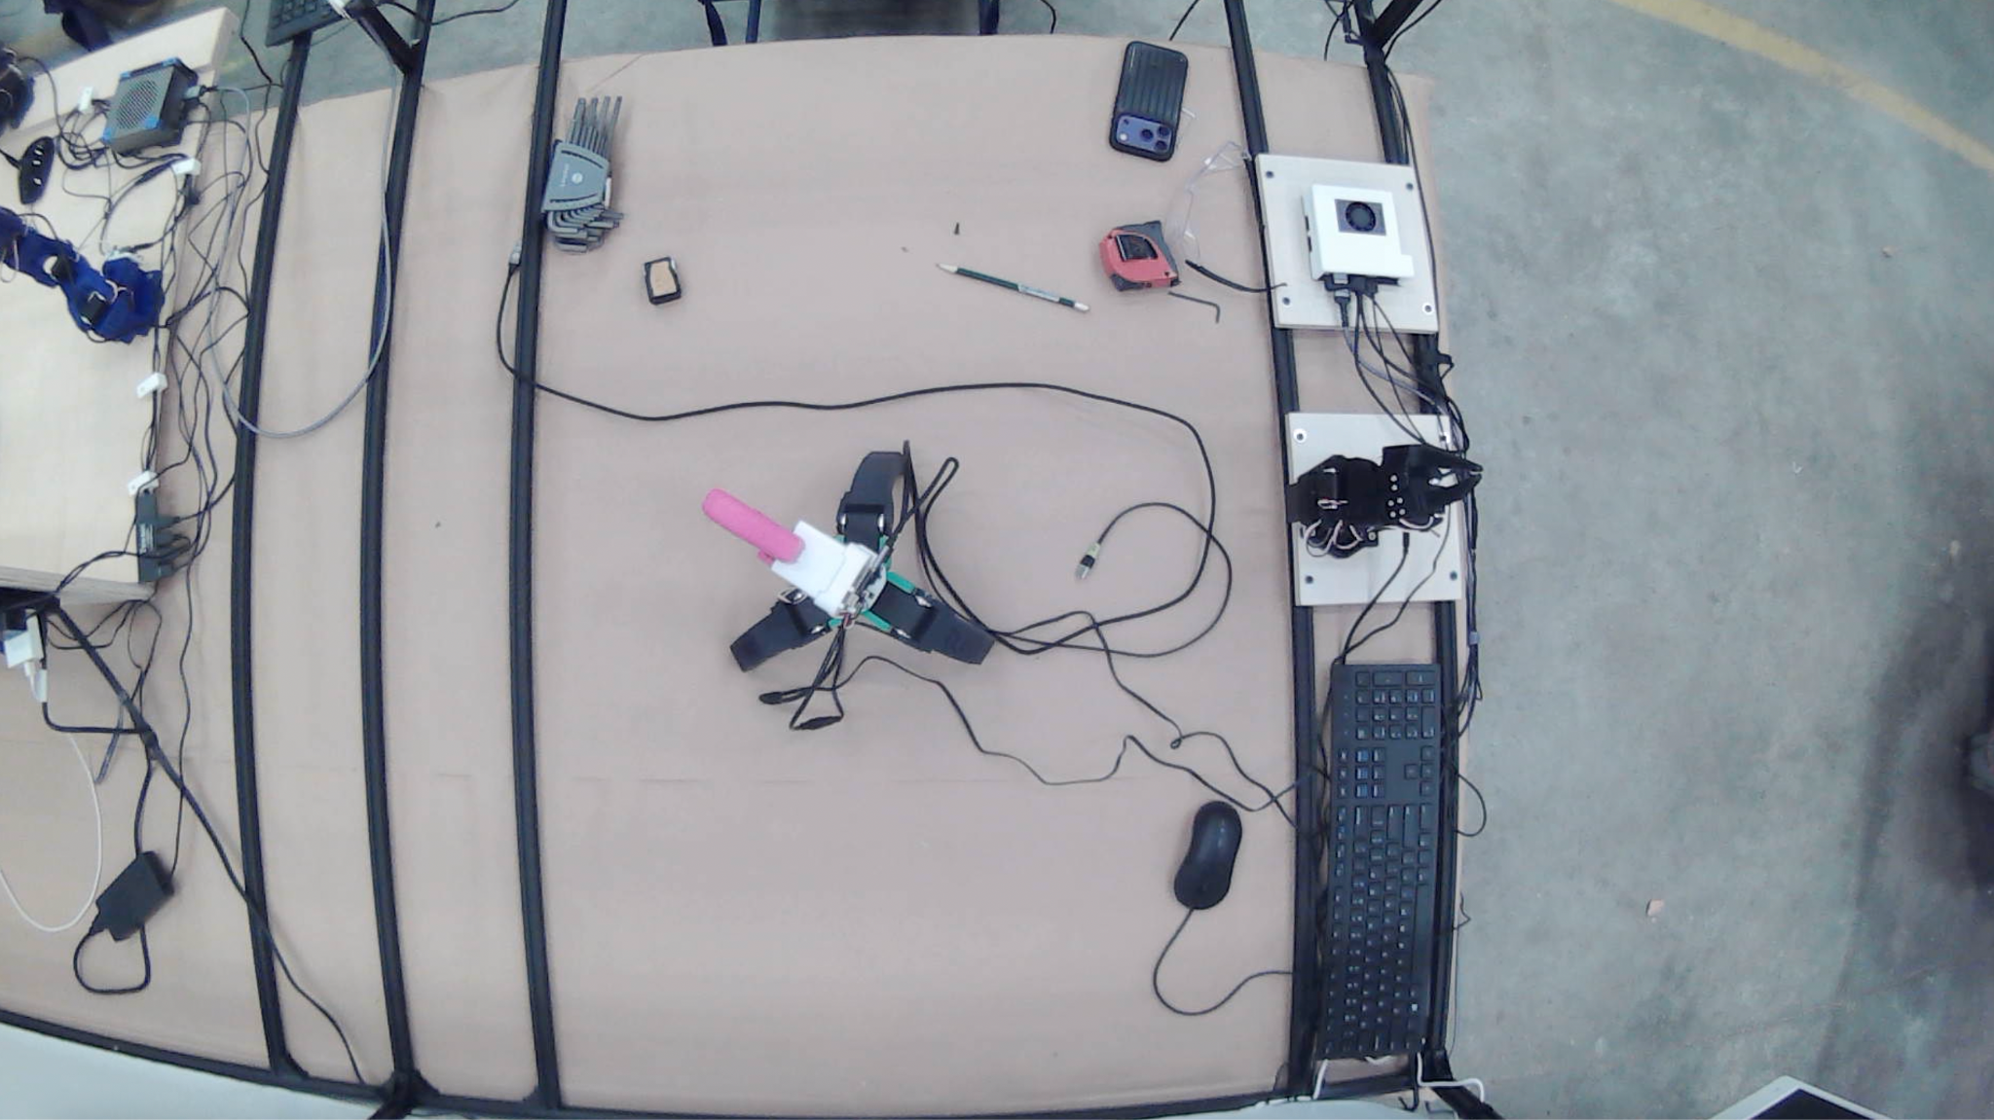

- This design was created with intent to capture the full work space from above. This FOV allows us to see the overall workspace, especially if working with multiple training arms or grabbing lettuce which requires a bigger space. Since the camera points straight down, I did not have to create a fancy mount to reach the FOV I needed. So, I reused Prototype 1 from the training arm as is and mounted it to the middle of the bar going straight across the top.

Fig.5 - Prototype 1 Mount Fig.6 - Bird’s Eye View of Work Space

Angle Bar:
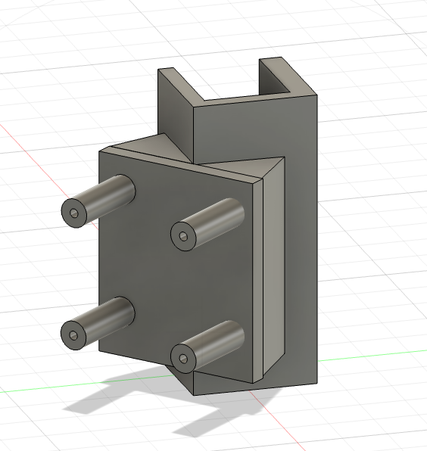
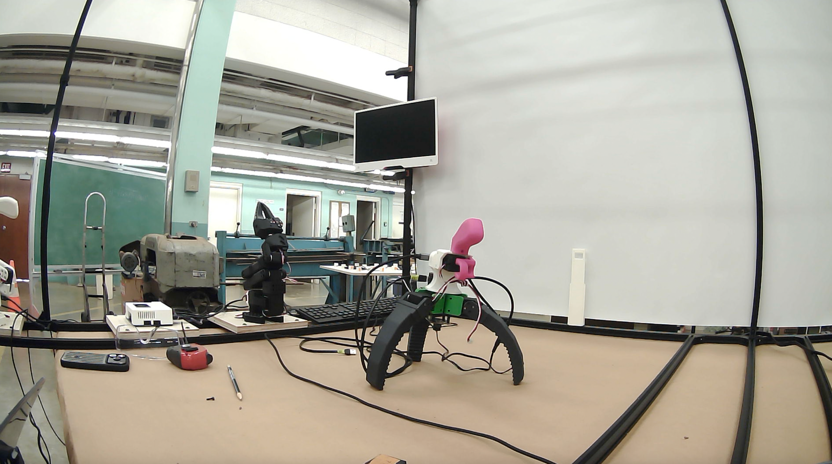
- This design was created to capture the workspace from an angled perspective. While top and side views provide useful coverage, an angled view offers a closer and wider perspective of ongoing activities. The mount attaches to the metal bars and positions the camera to effectively capture the workspace at this angle.

Fig.7 - Bar Mount Fig.8 - Angle View of Work Space
Back View:
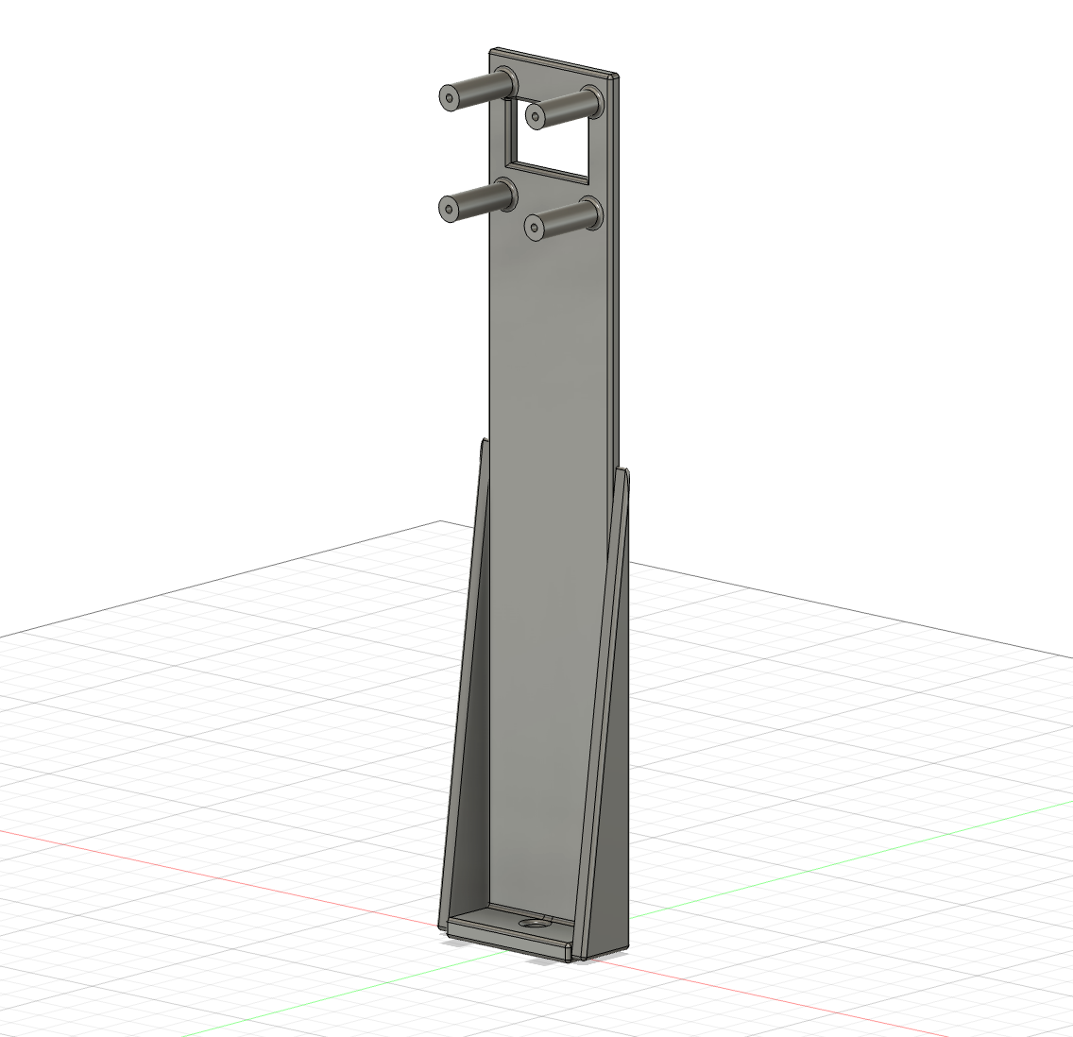
- This design was created to capture the workspace from the rear. It helps show areas that aren’t visible from the front or top, like what’s happening behind equipment or along the back side of the setup. This reduces blind spots and gives a more complete view of the workspace. The mount attaches to the metal bars and positions the camera to monitor from behind.

Fig.9 - Back View Mount Fig.10 - Back View of Work Space

What to Look for in Choosing a Camera
- The purpose of calculating megapixels and field of view (FOV) for each camera setup is to determine how much of the scene the camera can capture and how detailed the image will be. In this analysis, the main focus is on FOV, since it shows the physical area visible to the camera. A larger FOV allows more of the environment to be seen, while a smaller FOV provides a more zoomed-in and detailed view of a smaller area. By comparing different setups, the goal is to find a balance between capturing enough of the scene and maintaining sufficient image clarity. Based on the results, the selected camera setup is the one that provides a reasonable FOV without excessive distortion, while still maintaining adequate resolution for clear observation.

Results
To determine the appropriate cameras, the workspace (left section) was first measured to be approximately 1.022 m × 1.212 m × 1.257 m, with a corner-to-corner distance of 1.702 m. These values were used as the target field of view (FOV) needed for each camera setup.
FOV data was collected using an Innomaker 1080P and Innomaker 720P USB camera with different lenses (standard, 2.8 mm, and 180° fisheye). A beam level was placed in the camera view, and a scale factor was calculated using: real length ÷ pixel length. This scale was then used to convert image pixel dimensions into real-world FOV width and height.
At a distance of 2 m:
- Innomaker 1080P (2.8 mm lens) → ~3.2 m × 1.8 m
- Innomaker 1080P (fisheye lens) → ~5.6 m × 3.2 m
- Innomaker 720P (2.8 mm lens) → ~2.1 m × 1.2 m
The main factor used to determine camera selection was whether the FOV width and height matched or slightly exceeded the workspace dimensions (~1.02 m × 1.21 m). Setups with smaller FOV could not capture the full area, while fisheye lenses provided more coverage with some distortion.
Based on this:
- The middle of the setup uses an Innomaker 1080P with a 2.8 mm lens for full workspace coverage with clear detail.
- The training arm uses an Innomaker 1080P with a fisheye lens to capture a wide view of the gripper and lettuce.
- The corner of the setup uses an Innomaker 720P with a 2.8 mm lens to provide additional coverage and reduce blind spots.

Summary
This section focused on designing a multi-camera system for the robotic arm and workspace. The workspace was measured first, and field of view (FOV) data was collected using Innomaker 1080P and 720P cameras with different lenses and distances. A ruler-based method was used to convert pixel measurements into real-world FOV values to compare each setup with the workspace size. Camera choices were made based on which setups best matched the workspace dimensions while maintaining clear image quality. The 1080P camera with a 2.8 mm lens was used for the main view, the fisheye lens for the training arm to capture wide motion, and the 720P camera for corner coverage to reduce blind spots. Overall, the system provides full coverage, stable mounting, and clear views for tracking robot movement.

Software controls and scripts for motor control

Deliverable - R2
Mount/integrate external cameras to track objects and assist the robotic arm, designing mounts that are stable, and withstand vibration/shakiness during operation.

Functional scripts compatible with various end effectors designed for greenhouse tasks.

Requirements
Lettuce specs and other requirements such as payload.

Generalized script capable of operating multi-jointed end effectors, multi-motor joints, and arm itself.

Design or Justification - Process

Software
During the calibration process, the range of motion of each motor, under a 12-bit resolution, in both leader and follower arms are recorded and converted into a range from -100 to 100. Connected in a daisy chain, the ST3215 motors each have a unique motor ID and only receives signals from its counterpart in the other arm during teleoperation. Maintaining the single motor controller and three-pronged follower gripper design, the software must be capable of sending the positional information of one motor to three motors rather than the original one to one. This can be accomplished by directly updating the motor positions to that of the controller, without relying on the one to one set up before.

While the follower arm may have joints that contain multiple motors in order to increase its carrying capacity, the leader arm remains the same in all cases. A multi-motor joint requires the two motors to face in opposite directions, while also receiving the same command from a single motor in the follower arm, meaning that the command must be updated within the script before it is sent to the follower. If calibrated properly, this can theoretically be accomplished by reversing the signum of its positional command.

Results
Multi-Jointed End Effector
After modification of the configuration files, the robot has been capable of

Multi-motor Joints

Summary

AI Model Training for Tip Burn Detection

Deliverable - G1
Use image processing and train an AI model to detect browning in lettuce

Requirements
Pictures of the lettuce in different angles and stages of growth.
AI model (name)

Design or Justification

Results

Summary

Data Collection and Storage for Greenhouse Monitoring

Deliverable - G2
Store monitored data in a web server and recall data to populate dashboards and use AI to make growth recommendations.

Requirements
format ; type; etc.

Design or Justification

Results

Summary

Sensor Implementation for Environmental Monitoring and pH

Deliverable - G3
Fully integrate pH probe and amplifier to monitor pH levels of fish tank, including a solar energy source for it.

Requirements
Lettuce specs and other requirements such as payload.
3D printed bracket, with a hole where the probe is placed.
3D printed “weather stations”, where humidity and temperature sensors are placed.

Design or Justification
The bracket attaches to the tank lip with the tip of the probe submerged.
“Weather stations” are placed in various places around the green house to get humidity and temperature.

Results

Summary

References
All references must be listed in the references section and properly cited throughout the text of your document. The APA format for both citations and references must be used.

